* **COOLER MASTER SEIDON 120V PLUS LIQUID COOLING SYSTEM**

(pic on the site)

# THERMALTAKE FRIO EXTREME CPU FAN

**Detailed Feature**

**Ultimate Over-clocking Design Structure, support up to 250W**

* Dual tower heat-sink with 0.4mm aluminum fins provide large surface for heat dissipation.
* 6 x Ø6 mm-U-shape copper heat pipes accelerate heat conductivity.
* Mirror-finished copper base, provide perfect contact with CPU.
* Premium thermal grease maximizes heat transfer from the CPU onto the copper base for faster dissipation.

**The Combination of VR and PWM Control Function Fan**

* Dual 14cm high performance blue blade designed fans, spins from 1,200 to 1,800RPM.
* Combination of VR and PWM functions, switchable upon user’s preferences.
* Tool-less and Easy installation design for quicker disassemble and assemble the fan module.

**Universal Socket Compatibility & Accessory Package**

* All-in-one back-plate design, support all Intel and AMD platform
* Universal socket support :  
  Intel: LGA 2011, 1366, 1155, 1156, 775  
  AMD: FM1, AM3+, AM3, AM2+, AM2

**Dimension**

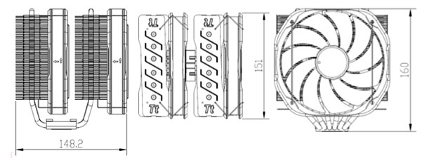

**Intel Motherboard Installation**

|  |  |
| --- | --- |
| **Step 1** | **Step 2** |
| http://www.thermaltake.com/db/products/cooler/FrioExtreme/intel/1.jpg | http://www.thermaltake.com/db/products/cooler/FrioExtreme/intel/2.jpg |
| Insert the four long screws through the back-plate into the four holes on the motherboard and secure them with the four plastic spacers evenly. | Put the two Intel mounting bars along with the four long screws and secure them with the four nuts. |
| **Step 3** | **Step 4** |
| http://www.thermaltake.com/db/products/cooler/FrioExtreme/intel/3.jpg | http://www.thermaltake.com/db/products/cooler/FrioExtreme/intel/4.jpg |
| For LGA2011: Screwing the LGA 2011 screw onto motherboard tightly and put the two Intel mounting bars on the LGA 2011 screws. Fasten the four nuts onto the mounting bars tightly. | Install the fan clips onto the heat-sink separately |
| **Step 5** | **Step 6** |
| http://www.thermaltake.com/db/products/cooler/FrioExtreme/intel/5.jpg | http://www.thermaltake.com/db/products/cooler/FrioExtreme/intel/6.jpg |
| Applying a thin layer of thermal grease onto the CPU. | Screw the heat-sink onto the motherboard with the mounting plate tightly. |
| **Step 7** | **Step 8** |
| http://www.thermaltake.com/db/products/cooler/FrioExtreme/intel/7.jpg | http://www.thermaltake.com/db/products/cooler/FrioExtreme/intel/8.jpg |
| Fix the two fans onto the heat-sink with fan clips separately. | Connect two fan cords to the controller close to the VR Knob. Link the power cord to the CPU FAN slot and the right slot of the controller. |
| **Step 9** |  |
| http://www.thermaltake.com/db/products/cooler/FrioExtreme/intel/9.jpg |  |
| Connect the 4-pin wire of controller to the motherboard’s CPU fan connector. Installation is done. |  |

**AMD Motherboard Installation**

|  |  |
| --- | --- |
| **Step 1** | **Step 2** |
| http://www.thermaltake.com/db/products/cooler/FrioExtreme/amd/1.jpg | http://www.thermaltake.com/db/products/cooler/FrioExtreme/amd/2.jpg |
| Insert the four long screws through the back-plate into the four holes on the motherboard and secure them with the four plastic spacers evenly. | Put the two AMD mounting bars along with the four long screws and secure them with the four nuts. |
| **Step 3** | **Step 4** |
| http://www.thermaltake.com/db/products/cooler/FrioExtreme/amd/3.jpg | http://www.thermaltake.com/db/products/cooler/FrioExtreme/amd/4.jpg |
| Install the fan clips onto the heat-sink separately. | Applying a thin layer of thermal grease onto the CPU. |
| **Step 5** | **Step 6** |
| http://www.thermaltake.com/db/products/cooler/FrioExtreme/amd/5.jpg | http://www.thermaltake.com/db/products/cooler/FrioExtreme/amd/6.jpg |
| Screw the heat-sink onto the motherboard with the mounting plate tightly. | Fix the two fans onto the heat-sink with fan clips separately. |
| **Step 7** | **Step 8** |
| http://www.thermaltake.com/db/products/cooler/FrioExtreme/amd/7.jpg | http://www.thermaltake.com/db/products/cooler/FrioExtreme/amd/8.jpg |
| Connect two fan cords to the controller close to the VR Knob. Link the power cord to the CPU FAN slot and the right slot of the controller. |  |

# THERMALTAKE FRIO OCK CPU FAN

Designed for Over-clocker King, the Thermaltake Frio OCK boasts a whooping heat dissipation capacity of 240 W which is clearly leading the pack. The Frio OCK comes with six 6mm high-efficiency U-shape heat pipes that effectively transport heat from the nickel-coated copper base into the giant dual-tower heatsink featuring 0.4mm aluminum fins. Also included are dual powerful 130mm VR OC fans, each of which can generate a massive airflow of up to 121 CFM for intense heat dispersion. Fan speeds are adjustable from 1,200 to 2,100rpm using the included VR controller.

Frio OCK’s design concept captures and embodies currently prevailing computer game elements, in particular the dazzling cover is resembling a firm and powerful Bunker as inspired by the popular PC game StarCraft II. Besides top-notch performance, particular attention is paid to ease-of-use, convenience and compatibility with a universal installation kit for all current Intel and AMD sockets including LGA1155. With Frio OCK, it probably has never been easier to become a true Overclocking King in your own right.

* newegg*ULTIMATE OVERCLOCKING THERMAL STRUCTURE DESIGN, SUPPORT UP TO 240W.*Premium thermal grease, nickel-plated copper base and 6 U-shape heat pipes maximize heat transfer from the CPU into the giant dual tower heatsink for rapid dissipation. In addition, the heatsink with 0.4mm aluminum fins provides large surface for heat dissipation, while tower side flow design efficiently increases airflow and ventilation created by the dual fans.
* newegg*DUAL 130MM VR OC FANS* Both fans are designed to work in tandem as a push-pull-combination where one fan pushes cold air over the tower fins, while the other fan on the opposite site pulls out hot air and then exhausts it through the case’s back side. A convenient single VR control knob adjusts both fans in parallel to guarantee optimized airflow and maximize cooling efficiency. The 130mm high pressure OC fans can be tuned between 1200 RPM for normal quiet operation and up to 2100 RPM under extreme OC circumstances.
* newegg*UNIVERSAL SOCKET COMPATIBILITY* The Frio OCK comes with an all-in-one back plate design supporting all mainstream Intel and AMD platforms including Intel LGA 1366/1155/1156/775 and AMD AM3/AM2+/AM2.

# THERMALTAKE WATER 3.0 EXTREME-S CPU FAN

* 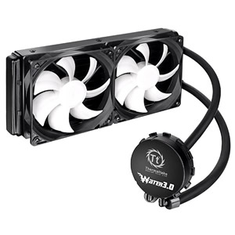**Water 3.0 Extreme S**
* When choosing a high-efficiency liquid cooler to control roaring CPU temps, enthusiasts crave an easy, clean, and low-maintenance setup. The new Thermaltake All-In-One LCS Water 3.0 Series is designed to exceed user expectations. One simple upgrade allows users to enjoy better cooling performance and greater CPU protection.
* 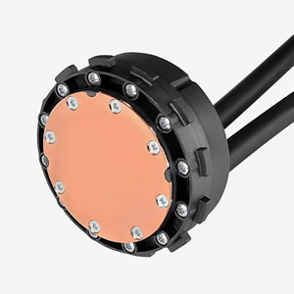**High Performance Waterblock**
* Full copper base plate maximizes heat conductivity while improving the case’s airflow.
* 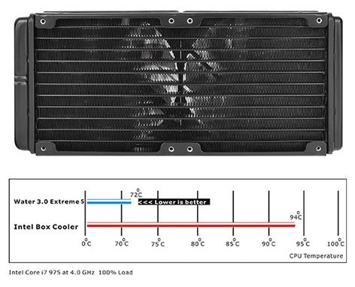
* **High Efficiency Radiator**
* Especially designed 240mm large surface radiator, supported by two more 120mm fans for additional heat dissipation.
* 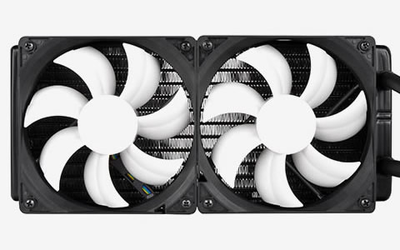
* **Double Curved Fan**
* Powerful PWM controlled fan spins between 1200~2000rpm, blowing radiator heat out to the chassis to maximize cooling performance.
* 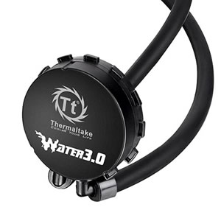**High Reliability Pump**
* The high quality, reliable pump enables maximum water circulation and keeps the copper plate continuously cool.
* 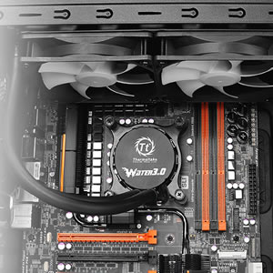**Easy and Simple Installation**
* The Water 3.0 Series features the latest cooling performance technology from Thermaltake, providing simple installation and totally maintenance-free operation. Unlike full-blown air coolers, the Water 3.0 series is easy to install and doesn’t take up much room in your case.

# XIGMATEK JANUS LD1266 120/80MM CPU FAN

Janus is the god of beginnings and transitions, gates, doors, endings and time. Janus is a two-faced god which has the ability to look into the future and past. Xigmatek continues to innovate once again, this time adopting Janus to be the name that will be heard for many years to come in the CPU cooling industry. Janus is one of the world’s thinnest low-profile coolers. Standing at a height of 60mm Janus can virtually fit in any case

# XIGMATEK PRAETON LD963 CPU FAN

The Xigmatek PRAETON LD963 is an intelligent evolution of the original LD964 design. The redesigned PRAETON LD963 focused on improving both thermal efficiency and cost. Despite reducing the number of 6mm heatpipes from four to three, the LD963 performs better than its predecessor while still maintaining the same compact form-factor. The PRAETON LD963 is capable of handling up to 115W of heat generated by the CPU. Paired with a 90mm 4-pin PWM fan for silent and efficient operation, the PRAETON LD963 provides excellent performance and value for your money. The PRAETON LD963 supports Intel Socket LGA 1366/1150/1156/1155/775 and AMD Socket FM1/FM2/FM2+/AM2/AM2+/AM3/AM3+.

# ZALMAN CNPS14X CPU FAN

CPU cooling is key to entire system stability and reliability, especially for the gaming rig with high-end power-consuming processor. Designed with this in mind, the Zalman CNPS14X CPU cooler offers a perfect solution for professionals and over clockers seeking uncompromised performance at unbeatable price. Six double-efficiency heat pipes penetrate dense aluminum fin array to efficiently take and spread the heat generated by CPU, while a low-RPM 140mm fan blows cool air through the fin surface without adding much noise. Comprehensive compatibility with Intel and AMD platform makes the CNPS14X an all-round athlete and effectively protects your investment.

* newegg*IHD TECHNOLOGY*IHD (Interactive Heat pipe transfer Design) Technology applied to keep your computer running smooth and stable. With height less than 160mm it fits in a variety of cases including mid case (width 180mm).
* newegg*‘U’ TYPE DUAL HEATSINK*U-shape dual heat sink is designed to maximize the dissipation area. Plus the aerodynamically constructed double-induction heat sink increases the airflow maximizing cooling performance.
* newegg*HIGH QUALITY BASE* Zalman’s unique sanding process provides excellent heat transfer ability.
* newegg*ULTRA QUIET 140MM FAN* Running at 950 – 1350 RPM (+/-10%) and 17 – 21 dBA (+/-10%) noise level, the frameless 140mm ultra quiet middle fan dissipate heat quickly and silently. You can also add two extra 140mm fans (sold separately) to boost the thermal performance, ideal for over clockers and power users.
* newegg*ZM-STG2M*High performance ZM-STG2M thermal grease helps to maximize the heat transfer from CPU to base allowing optimal cooling performance.
* newegg*HIGH COMPATIBILITY* Compatible with Intel LGA 775/1155/1156/1366/2011 platform and AMD AM2/AM2+/AM3/AM3+/FM1 platform.